

**Holland Park Kindergarten Association Inc.**

**ENROLMENT PROCEDURE**

Holland Park Kindergarten Association (HPK) believes in maintaining strong community and family connections across generations of ‘Kindy families’ whilst offering a transparent, fair and equitable waiting list procedure.

HPK aims to ensure that the enrolment process proceeds smoothly and meets the needs of each child, their families and the Kindergarten community.

# QUEENSLAND KINDERGARTEN FUNDING SCHEME AND UNIVERSAL ACCESS

|  |  |
| --- | --- |
| **Child Born** | **Year of entry** |
| 1 July 2020 to 30 June 2021 | 2025 |
| 1 July 2021 to 30 June 2022 | 2026 |
| 1 July 2022 to 30 June 2023 | 2027 |
| 1 July 2023 to 30 June 2024 | 2028 |
| 1 July 2024 to 30 June 2025 | 2029 |

HPK is a Queensland Government Approved Kindergarten Program provider. HPK is entitled to claim the Queensland Kindergarten Funding Scheme (QKFS) on behalf of children enrolled at our Centre. This funding is only provided to eligible aged children (turning 4 by June 30th in the year they attend kindergarten) for the equivalent of one 15 hour per week program, for a minimum of 40 weeks per year. The policy of Universal Access to Kindergarten ensures all children receive the benefit of attending a Kindergarten Program and adds an additional element to the criteria for enrolments.

## Applying for the Waiting List

All families will need to complete the Waiting List Application Form and open a XAP account, available via our website. This creates a XAP profile for the child.

Siblings of past/current children, need to have their waiting list application submitted and approved, 2 years prior to the “Year of Entry” (eg if your child is due to commence in January 2027, then we need to have approved your waitlist application prior to January 2025).

HPK Admin will send a Waitlist confirmation email. This email will also include:

# acknowledgment of completion of registrstration for Waitlist

# advise families that this does not guarantee a place at the centre, nor in the group of their choice.

# advise families that it is their responsibility to ensure they keep all of their details up to date, including the group they wish their child to attend (ie: Kookaburra or Gecko).

# advise families of the Smile app and the need to instal the app as it is through this channel that future offers will be made

# families on the waiting list may contact the Kindergarten to review their progress on the waiting list at any time.

# Parents/guardians wishing to withdraw their waiting list application are requested to let the Administration/Finance Officer know as soon as possible via email [admin@hollandparkkindy.com](mailto:admin@hollandparkkindy.com)

# Information re: any up coming kindy events eg Come and Play or Community Open day

# information re: how offers are made

HPK admin will place children on the waiting list in strict accordance with the child’s date of accepted registration.

## Offer of Placement/Enrolment for the following year

Places will be allocated to children who are on the waiting list in accordance with their position on the waiting list, and the following criteria:

1. Children who will be continuing from their current year (delayed exit)
2. Siblings enrolled 2 years prior to Year of Entry
3. Waitlist enrolment date

HPK Admin will send an email outlining the placement offer available to each eligible family. The offer will also come through the XAP Smile app that prospective parents should have installed on their device. The email will include:

# offer of a position for the following year and comfirmation of group

# details of how to complete the full Enrolment Form on the XAP Smile App or XAP Parent Portal prior to the end of T4.

# details of how to pay Enrolment deposit

# families with Health care cards to provide a copy to Admin, upon receipt Enrolment Levy will be cancelled.

# families are informed of the estimated additional fees for the Gecko group.

Once a place is offered to a child, the parent or guardian must confirm acceptance of the offer via email and/or with the Smile app, within 5 business days.

To confirm and secure the position each family must

# provide a completed Acceptance Form

# provide a completed Membership application form

# provide a copy of Birth Certificate and Immunisation Register

# pay enrolment deposit

HPK Admin will email families a receipt/acknowledgment of acceptance, which will include the date of the Parent Information Session.

If the family does not want the place at that particular time, they may choose to remain on the waiting list, but they will be placed at the end of the waitlist.

If no contact has been received by HPK in relation to the offer after 5 business days then the offer will lapse and the place will be offered to the next child on the waiting list.

## Enrolment Deposit

An enrolment deposit will be requested with the letter of offer. Typically the annual enrolment deposit will include the following:

1. $10.00 membership fee to the Holland Park Kindergarten Association, and
2. $100 Enrolment Levy

## Parent Enrolment Information Night (typically end of October)

Families will be given an acceptance package that will include:

# Parent handbook

# start dates and yearly calendar

# interview date and time for week Zero

# details of the Annual General Meeting (AGM) and Welcome BBQ

# date of first working bee

# Committee Nomination Form

# Parent Code of Conduct form

Educators will inform families about

# the program, especially routines for the first few days

# what to bring

# invite parents to ask questions

# have sheet sets, hats, T-shirts, wet bags available

# remind parents of paperwork to be completed before commencement

# fees and payment options, necessary paperwork

# HPK policy and procedures

# parent responsibilities

# ways to be involved in the program and the kindy community

**Week Zero Enrolment Interviews**

In the week prior to the commencement of a kindy year each family will be encouraged to attend an enrolment interview.

These will be held in small groups (usually 1 hour sessions) to allow children the opportunity to meet other children and become familiar with the kindy setting.

Educators and families will also have a chance to share information relevant to their child starting kindy.

Educators will:

# ensure all paperwork is complete

# discuss child’s likes, needs, family, culture, rest, pickup and drop off arrangements etc

# discuss medical information and complete appropriate action plans/forms

# discuss goals for transitioning and start of the year

# ensure parents are aware of how to sign in and out using Ipads

**Extra information**

**Late Enrolment:**

Families are able and encouraged to complete waiting list forms throughout the year.

Before offering positions throughout the year the Nominated Supervisor and the Management committee will assess the feasibility of taking on an extra enrolment dependant on our groups circumstances at the time.

If a position is available families will need to

# attend an enrolment interview

#respond to an offer within 24 hours

# complete all paperwork

Where a child is enrolled at any time that is not at the start of the Kindergarten Year, the official commencement date will be the date agreed on at the time of the enrolment interview and fees will be payable from this date. This will apply regardless of whether the child starts on this date or not.

**Withdrawal:**

Families are required to give 4 weeks’ notice in writing of their intention to withdraw their child from the Kindergarten or pay fees in lieu of notice. This will also apply to families who withdraw from a place prior to their child’s official commencement date.

**Delayed Exit:**

Delayed Exit enrolments are based on communication and agreement between parents/guardians and the Nominated Supervisor.

Educators need to ensure these conversations occur prior to offers being made so that positions can be held.

It is preferred that these positions are finalised 2 weeks prior to the Parent Information Session.

**Contact information:**

It is the responsibility of the parents/guardians to ensure that the Kindergarten is notified of all changes to contact phone numbers, addresses, emergency contacts, persons authorised to collect the child, etc. This information can be updated by using the XAP Smile App or logging onto the XAP Parent Portal.

**Attending other Kindergartens:**

Due to the guidelines of the Free Kindy Funding, we cannot offer a child who is already enrolled in a Kindergarten Approved Program for their “Year of Entry”, a place at HPK until 28 February in their “Year of Entry”, and this would only occur if we have positions available.

**APPENDIX CONTENTS**

Appendix 1 - Enrolment Waiting List Form

- Enrolment Wait List Application

Appendix 2 - Reference to Website Waiting List Form

Appendix 3 – Free Kindy Funding

Related Policies Universal Access Policy

The Gowrie (Qld) Inc Access and Admissions Policy

The Gowrie (Qld) Inc Inclusion and Anti-bias Policy

The Gowrie (Qld) Inc Orientation and Communication Policy–Families and Children

The Gowrie (Qld) Inc Fees and Payment of Fees Policy (all available on request).

# EVALUATION

In order to assess whether the procedure has achieved the values and purposes set out in the Policy Statement, the Committee will:

* Assess the effectiveness of the process
* If appropriate, conduct a survey in relation to this procedure or incorporate relevant questions within the general parent/guardian survey.
* Take into account feedback from staff regarding the procedure.
* Monitor complaints and incidents regarding the procedure.

# AUTHORISATION

This procedure was adopted by the Holland Park Kindergarten Association Inc. Committee of Management, at the committee meeting on _____ October 2024.

# REVIEW DATE

This procedure will be reviewed at least annually in June by the Management Committee of Holland Park Kindergarten Association Inc.

**APPENDIX 1**

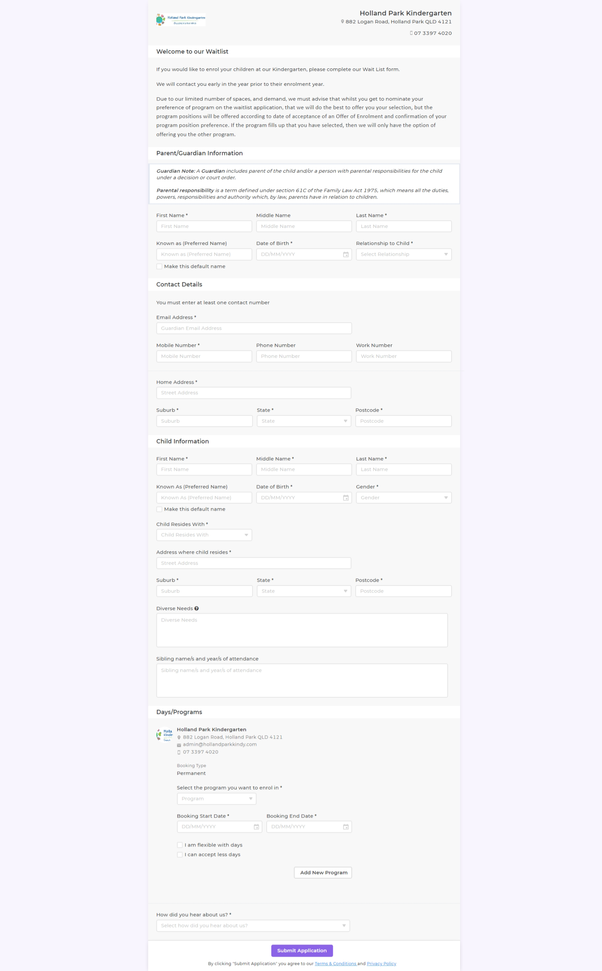

|  |  |
| --- | --- |
| **Child Born** | **Year of entry** |
| 1 July 2020 to 30 June 2021 | 2025 |
| 1 July 2021 to 30 June 2022 | 2026 |
| 1 July 2022 to 30 June 2023 | 2027 |
| 1 July 2023 to 30 June 2024 | 2028 |
| 1 July 2024 to 30 June 2025 | 2029 |



**WAIT LIST APPLICATION FORM**

Your child can be placed on our waiting list from birth. This does not guarantee your position, as positions are offered in order of receipt of form and wait listing on XAP, except for siblings, who must have been accepted on our waitlist 2 years prior to their “Year of Entry”. Siblings registered as required, are given second preference, after children who will be continuing at Kindy from their current year. There is **NO** fee to waitlist.

The enrolment process usually begins in June of the year prior to entry.

Full Name of Child: ___________________________________________________ Male/Female (please circle)

Date of Birth: _____/_____/______ Date of Application: ______/______/_______Year of attendance: ________

Parent 1:________________________________________________________________________________________

Phone: _________________________________ (Mobile) ________________________________ (Alternate, if any)

Address: ________________________________________________________________________________________

Email: __________________________________________________________________________________________

Parent 2:________________________________________________________________________________________

Phone: _________________________________ (Mobile) ________________________________ (Alternate, if any)

Address (if different to above): ________________________________________________________________________

Email: __________________________________________________________________________________________

We offer two programs of either 2 or 3 days per week (nominate preference by entering 1 and/or 2)

Mondays and Tuesdays 8am – 3.30pm 🞎

Wednesdays, Thursdays and Fridays 8.30am - 2.30pm 🞎

Does your child have any additional needs/disabilities/developmental delay? No🞎 Yes🞎

If yes, please provide details in the space below.

|  |
| --- |
|  |

If your child has had siblings previously attend the kindergarten program at HPK please include their details.

Name/s: _________________________________________________Year/s:_________________________________

Has your child previously been in an education and care program? No🞎 Yes🞎

Details of previous education and care program: _____________________________________________________

________________________________________________________________________________________________

Will your child be attending another Early Childhood Program in their intended year of enrolment? No🞎 Yes🞎

Details: _Centre:_________________________________________________Room:___________________________

Do you have an Australian Government Health Care Card? No🞎 Yes🞎 CRN: __________________________

**APPENDIX 2**

<http://www.hollandparkkindy.com/kindy/kindy-enrolment-form/>

<http://www.hollandparkkindy.com/kindy/kindy> waitlist XAP

**APPENDIX 3**

## Queensland Government Kindergarten Funding Scheme

Free Kindy is designed to ensure that Eligible Children receive 600 hours of fee-free kindergarten, removing cost as a barrier to access and relieving cost of living pressures for families. The Department of Education (the Department) will provide Free Kindy funding for a maximum of 40 weeks in a calendar year.

## Where a child is enrolled in an Approved Kindergarten Program in both a funded Sessional Kindergarten and a funded Long Day Care Service, the Sessional Kindergarten will receive Funding for the child.

## An Eligible Child cannot be enrolled in two programs at two different services until after the beginning of February, provided there are places available. To avoid doubt, families can only receive Funding for one Approved Kindergarten Program. Sessional Kindergartens are responsible for ensuring reasonable steps are taken to minimise Claims for Funding for Eligible Children who may be enrolled in more than one Approved Kindergarten Program.

## This could be achieved by including a question on the enrolment form seeking this information and then following up with the family to determine the Sessional Kindergarten or Approved Kindergarten Program for which Funding will be claimed. Where an enrolment form requires information from a family regarding enrolling in another Approved Kindergarten Program, the family is responsible for the accuracy of the information provided. If another Sessional Kindergarten is claiming Funding for an Eligible Child, the child’s enrolment record should indicate that they are ineligible for Funding under the second Approved Kindergarten Program.

## Universal Access Policy

## Sessional Kindergartens must have clear and transparent kindergarten enrolment processes and must ensure their application and enrolment policies:

## promote fair and equitable access to Approved Kindergarten Programs

## support all Eligible Children to access an Approved Kindergarten Program, including those who face barriers to participation

## do not inadvertently present barriers to participation, especially for Eligible Children experiencing vulnerability or disadvantage.